Google Ads Account Setup,Campaign Type & Objective ,Keyword Match Type
Tasks
1.
Create a new Google Ads account using your Gmail ID and take a screenshot of the account dashboard after setup.
2.
List three campaign types available in Google Ads and, for each, give a real-world example using an app you use daily (e.g., promote a new Zomato offer, advertise a Flipkart sale, or get more installs for a music app like Spotify).
3.
Choose a campaign objective in Google Ads (like Website Traffic, App Promotion, or Leads) and explain in 3-4 lines how this objective would help a brand like Myntra or BookMyShow achieve its marketing goals.
4.
For the keyword 'online food delivery', write one example each for Broad Match, Phrase
Match, and Exact Match types as you would enter them in Google
Ads.<br><br><em><strong>Hint:</strong> Use the correct syntax for each match type (no symbols, quotes, or brackets for Broad Match; quotes for Phrase Match; square brackets for Exact Match).</em>
5.
Use ChatGPT to generate a list of 10 potential keywords for a campaign promoting a new cricket score app during IPL season, then categorize each keyword as either Broad, Phrase, or Exact Match type.

1. Create a Google Ads Account
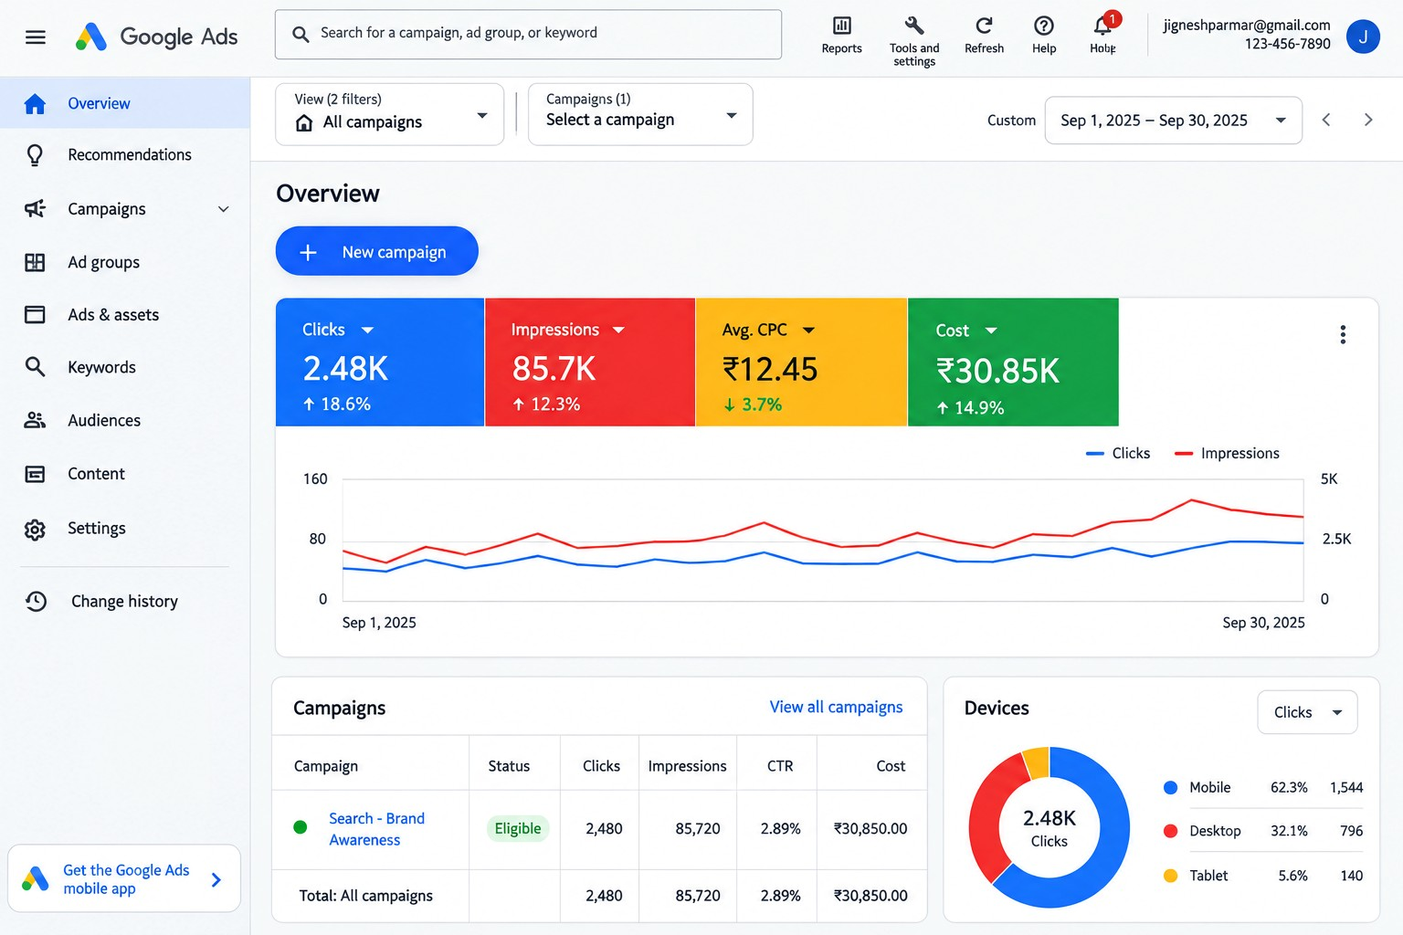

2 Three Google Ads Campaign Types
Campaign  Type | What it does | Real-world example
Search  Campaign | Shows text ads when people search on Google. | Zomato: Advertise “Food Delivery Near Me” to get more orders.
Display  Campaign | Shows visual/banner ads across websites and apps. | Flipkart: Promote its Big Sale with banner advertisements.
App  Campaign | Helps promote a mobile app and increase installs or actions. | Spotify: Advertise the Spotify app to increase new app installs.

Short explanation:
Search Campaign: Useful when customers are actively searching for a product or service.
Display Campaign: Useful for building awareness and reaching people visually across Google's advertising network.
App Campaign: Useful for getting more app installs and encouraging users to take actions inside the app.

3. Campaign Objective

Selected Objective: Website Traffic
Suppose Myntra wants to promote a new fashion collection. It can use the Website Traffic objective to bring potential customers to its website or specific product pages. Google Ads can target people searching for products such as “new fashion collection” or “buy men's sneakers online.” More relevant website visitors can give Myntra more opportunities to generate product views and sales.

Example:
Brand: Myntra
Objective: Website Traffic
Goal: Bring more potential customers to the Myntra website.

4 Keyword Match Types
Keyword: online food delivery
Match Type Google Ads  Syntax | Example
Broad Match No symbols | online food delivery
Phrase Match Quotation marks | "online food delivery"
Exact Match Square brackets | [online food
delivery]

Easy way to remember:
- Broad: online food delivery
- Phrase: "online food delivery"
- Exact: [online food delivery]

5 10 Keywords for a Cricket Score App

During IPL
Campaign idea: Promote a new cricket score app during IPL season.
No. Keyword Match Type
- cricket score app Broad
- live cricket score Broad
- IPL live score Broad
- "live cricket score Phrase app"
- "IPL live score" Phrase
- "IPL cricket scores" Phrase
- "cricket score today" Phrase
- [live IPL score] Exact
- [cricket score app] Exact
- [IPL live score] Exact

